ZF LeSSIS
User manual

Elektroniksystem- und Logistik GmbH

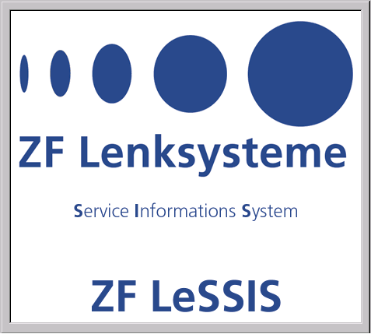

This manual was produced using Doc-To-Help®, by WexTech Systems, Inc.
Contents
General 1
Hardware and software requirements 1
Hardware 1
Software 1
Definition 3
Assembly, spare parts list and parts list 3
Installation and Start of ZF LeSSIS 4
Installation / Setup 4
Start installation 4
Deinstallation of earlier versions of ZF LeSSIS 7
Deinstallation of ZF LeSSIS 9
Installation of ZF LeSSIS 11
Start and Registration / Authorization 21
First steps with ZF LeSSIS 22
The entry in ZF LeSSIS 22
The user interface 24
The main window 24
The toolbar 24
The menu 27
The main search mask 31
The results windows 34
Selection of language 37
Data language 37
System language 38
Search in ZF LeSSIS 39
Spare parts lists / Parts lists / Assemblies 39
From the assembly group to the components 42
From the graphic to the assembly group or component 43
Search for spare parts in assemblies - parts application search 44
Search for Service Information documents and Repair Instructions 47
Survey of all Service Information documents and Repair Instructions 47
From the assembly group / component to the Service Information 49
Comparison of parts lists 51
Start of the parts lists comparison 51
Result of the parts lists comparison 51
Shopping cart 53
General 53
Items in the shopping cart 54
Export of a shopping cart 54
Printing 55
General 55
Start of printing 55
Parts lists (assemblies) 56
Assembly groups, components and footnotes 56
Graphics 56
Parts lists comparison 56
Shopping cart 57
Service Information documents / Repair Instructions 57
Contacts 58
Contacts 58

General

Hardware and software requirements

Hardware

Component | Minimum requirement
System unit | Commercial Pentium PC with 32 MB RAM
CD drive | 4-speed
Hard disk  Option 1: Data base on CD  Option 2: Complete on hard disk | At least 200 MB free  At least 850 MB free
Keyboard, mouse | X
Graphics board | Resolution 800 x 600  (recommended 1024 x 768)
Monitor | Resolution 800 x 600  (recommended 1024 x 768)
Printer | Windows-compatible printer  (recommended HP LaserJet series)

Software

- MS-Windows 95 OSR2,
- Windows 98
- Windows NT Workstation 4.0 (Service Pack 3 min.)
Note:
ZF LeSSIS does not run under Windows 2000 and Windows XP!

Definition

Assembly, spare parts list and parts list
The terms "assembly", "spare parts list" and "parts list" are used as synonyms in this User Manual.

Installation and Start of ZF LeSSIS

Installation / Setup

Note:
The installation steps described below are based on a standard configuration of the target computer. If your computer has a different configuration, the sequence of some installation steps can differ from the description.

Important Note:
It is strongly recommended to close all open applications and to restart the computer, before calling the setup.

Start installation
STEP 1: Start installation
The installation of ZF LeSSIS is carried out with the setup program "Setup.exe" on the CD "ZF_LESSIS_1".
→ Insert the CD "ZF_LESSIS_1".
→ Start the setup program "Setup.exe" on the CD "ZF_LESSIS_1" by a double click in the Windows Explorer or by the command "Execute" in the Windows start menu.

Then the following window is displayed:
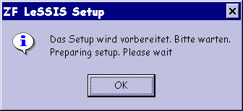
→ Please wait. The window closes by itself.
STEP 2: Select setup language
Next the window for selecting the setup language is displayed.
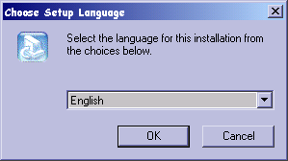
→ Select here the language in which you want to carry on the setup dialog.
→ Then click "OK".

STEP 3: Prepare installation
The setup program displays the ZF LeSSIS Splash Screen and prepares the InstallShield Wizard in the meantime.
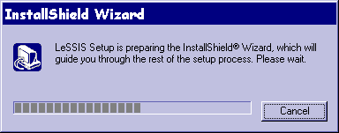
→ Please wait until the progress bar has been filled and the window is closed.

STEP 4: Welcome screen (can be dropped)
If an earlier version of ZF LeSSIS is installed on your computer, the welcome screen is now opened:
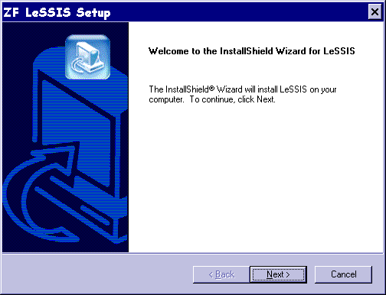
→ Continue installation by selecting "Next >".

Deinstallation of earlier versions of ZF LeSSIS
If an earlier version of ZF LeSSIS is already installed on your target computer, the same is now deinstalled automatically. To do so, the UnInstallShield of the existing version is executed.
Otherwise, the setup steps 5 and 6 are not carried out!

STEP 5: Acknowledge deinstallation
First you are asked if you wish to deinstall the version already existing.
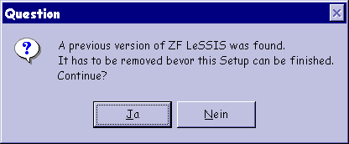
→ To continue the setup procedure, answer "Yes".

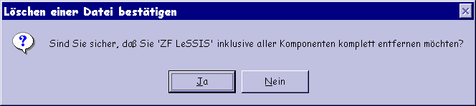
→ Please acknowledge your selection by clicking again on "Yes".

STEP 6: Carry out deinstallation
Now the UnInstallShield of the LeSSIS version on your computer is started, and the components of the old version of ZF LeSSIS are removed.
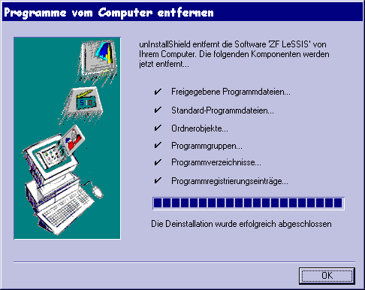
→ Please wait till deinstallation is completed.
→ Close the window by pressing the "OK" button.

Thereafter, the setup is continued automatically with the installation of ZF LeSSIS (continued with setup step 7).

Deinstallation of ZF LeSSIS
If ZF LeSSIS is already installed on your computer, this is now deinstalled automatically. To do so, the InstallShield Wizard is executed.
Otherwise, the setup steps 5 and 6 are not executed!

STEP 5: Acknowledge deinstallation
First you are asked if you wish to deinstall the version already existing.
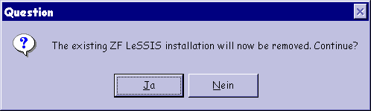
→ To continue the setup procedure, answer "Yes" (another acknowledgment is not required).

STEP 6: Carry out deinstallation
Now the InstallShield Wizard removes from your computer the components of the LeSSIS version already installed.
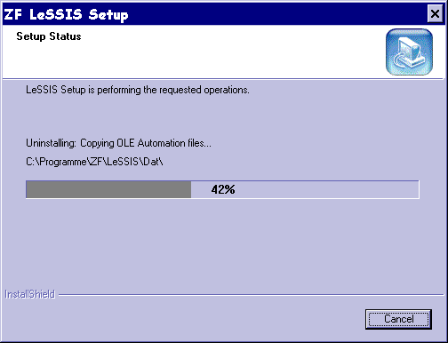
→ Please wait until deinstallation is completed and the end of the maintenance operation is indicated.

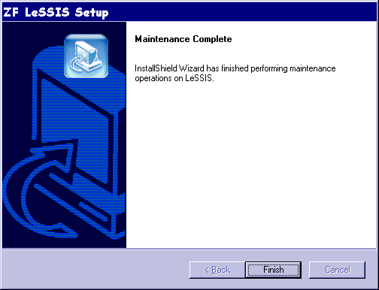
→ Close the window by actuating the "Finish" button.

To reinstall ZF LeSSIS you have to restart the setup.

Installation of ZF LeSSIS
If a ZF LeSSIS had not yet been installed on your computer, the setup is continued with the following steps:

STEP 7: Welcome screen (can be dropped)
The welcome screen is opened if you perform the first installation of ZF LeSSIS on your target computer.
→ Continue the installation by choosing "Next >".

STEP 8: Determine program path
Then a screen is displayed on which to choose the path of the destination to which the program components of ZF LeSSIS are to be installed.
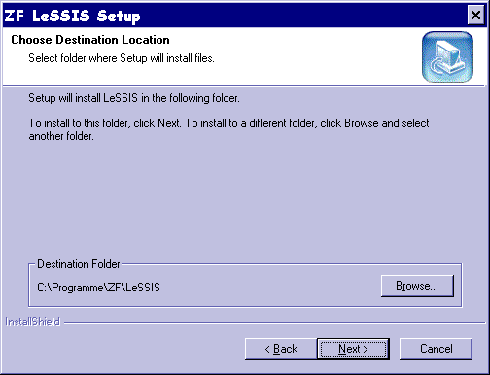
→ It is recommended to maintain the default! Alternatively, you choose the path of the destination to which the ZF LeSSIS program components are to be installed.
→ To continue click the button "Next >".

STEP 9: Choose setup type
ZF LeSSIS can be installed on your computer in two different configurations. Because of its large volume, the database is distributed over the two CDs supplied, i.e. "ZF_LESSIS_1" and "ZF_LESSIS_2". You can decide for yourselves whether only the data of CD 1 or the data of CD 2 as well are to be copied to your hard disk.
- Option 1: Disk space needed is 189 MB: Only the database contents of CD1 are installed on your computer. Then you need the CD no. 2 in the CD ROM drive during the run time.
Storage requirement: 189 MB
Advantage: You save space on the hard disk. Installation takes less time.
Disadvantage: Minimal loss of time in accessing data. You need CD 2 for the operation of ZF LeSSIS.
- Option 2: Disk space needed is 816 MB: The database contents of both CDs are installed on your computer. Then you don't need CD no. 2 during the run time.
Storage requirement: 816 MB
Advantage: Minimal gain of time in accessing data. You don't need a CD for operating ZF LeSSIS.
Disadvantage: This installation requires clearly more space on your hard disk. The volume of the data on CD no. 2 can be considerable!
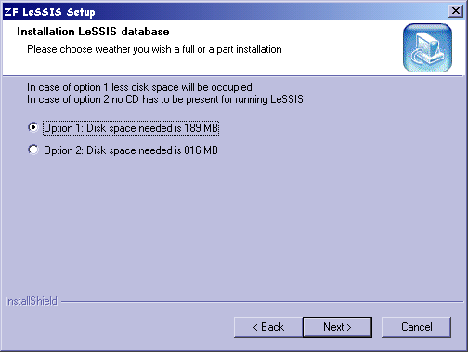
Default: "Option 1: Disk space needed is 189 MB"
→ It is recommended to retain the default! If you want to choose a setup type at that stage, keep the above criteria in mind.
→ Continue the setup by pressing the button "Next >".

STEP 10: Determine data path
Then a screen is displayed on which you are requested to choose the path of the destination to which the ZF LeSSIS database is to be installed (from CD 1 and, if applicable, from CD 2).
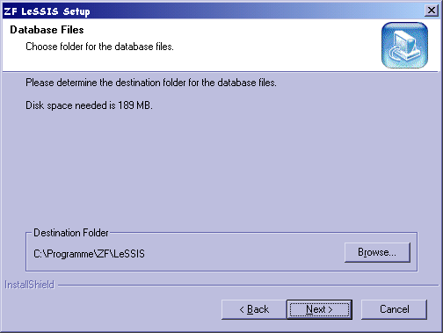
→ If you want to store the database in a place other than that of the program, please choose the path of the destination at which the ZF LeSSIS database is to be installed. In doing so, please allow for the space required on the hard disk.
→ To continue click the button "Next >".

STEP 11: Carry out the installation
The setup program now performs several steps during which various files are copied and installed and registry entries are created.
→ Please wait till the next steps have been carried out and the screens/dialogs displayed below have been completed.
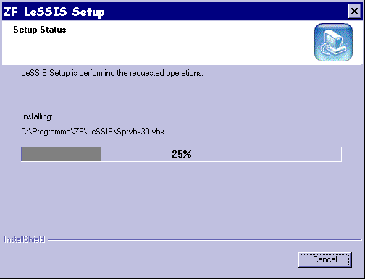
→ Please wait.

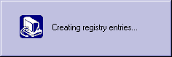
→ Please wait.

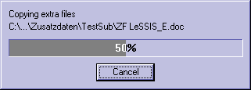
→ Please wait.

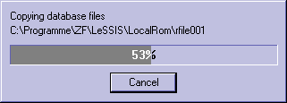
→ Please wait.

The next screen displayed requests you to insert the CD no. 2 "ZF_LESSIS_2".
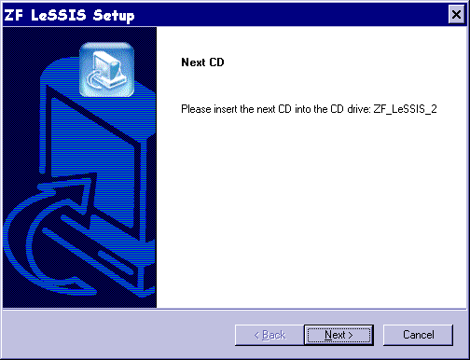
→ Please insert the CD no. 2 "ZF_LESSIS_2" in the CD ROM drive.
As soon as the CD has been accepted, you can continue the installation.
→ Click on "Next >".
The screen is maintained until you have inserted the right CD in the right drive!

If you install all database files from CD, you now see the following window (dropped if you install only the database files from CD 1):
→ Please wait.

Note:
During this step, it can happen that the Windows Explorer is opened in the foreground of your screen and receives the focus. In this case, please click on the background window of the still running setup program. You can continue the installation, as soon as the setup is back in the foreground.

Thereafter the database reference is created on your system.
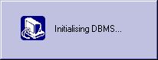
→ Please wait.

STEP 12: Finish the installation
If the Adobe Acrobat Reader ® 5.0 is not yet installed on your computer, you are now reminded that you can install the same from the CD no. 1 "ZF_LeSSIS_1" and that on finishing the setup LeSSIS is started automatically.
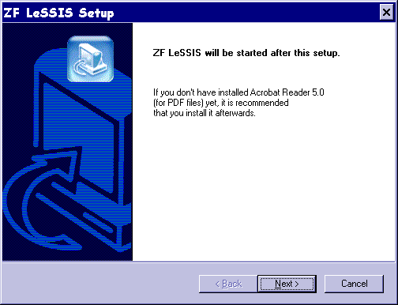
→ You continue the setup program by clicking "Next >".

The display of one of the next two screens completes the installation of ZF LeSSIS. (It depends on the configuration of your computer which screen you see.)
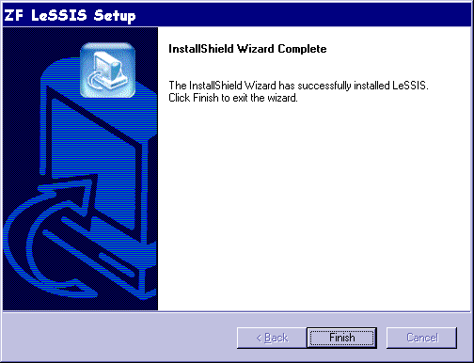9
→ When you see this screen, please acknowledge by clicking on the button "Finish".

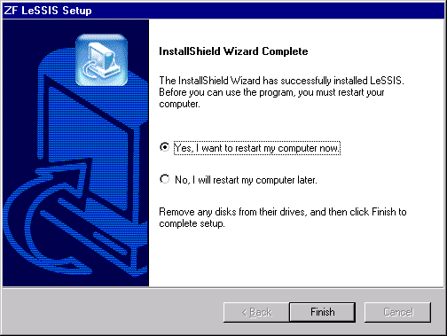
Default: "Yes, I want to restart my computer now."
→ When you see this screen, you should restart your computer in any case to make sure that ZF LeSSIS runs correctly after the setup!
→ Then please acknowledge by clicking on the button "Finish".

Note:
On completion of the installation/setup, ZF LeSSIS is started automatically (if you have not restarted your computer). Immediately after the first start, you must obtain authorization for the use of ZF LeSSIS.

Note:
As a display tool for Service Information documents and Repair Instructions, Acrobat Reader ® (from version 3.0) is necessary. The Acrobat Reader ® version 5.0 is supplied with ZF LeSSIS. You will find it in the subdirectory "Adobe" on the CD "ZF_LESSIS_1". If required, you can install Acrobat Reader ® from there.

Start and Registration / Authorization
On completion of the installation/setup, ZF LeSSIS is started automatically (unless you have restarted your computer).
Alternatively, you start the program via the start menu entry newly created after installation (start menu -> Programs -> LESSIS -> ZFLeSSIS) or double click on the ZF LeSSIS icon on your desktop.
Immediately after the first start you must obtain authorization for the use of ZF LeSSIS. To do so, the following authorization window appears:
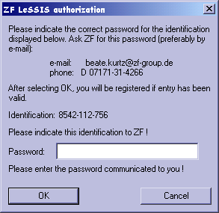

!!! New e-mail address:
Beate.Kurtz@ZF-Lenksysteme.com

The dialog window states the user identification. By means of this identification the user gets his password from ZF. The correct password has to be entered in the dialog window. If the correct password is entered, the user gets the authorization to use ZF LeSSIS.
→ With the identification please immediately request the password from ZF Lenksysteme GmbH and enter it immediately afterwards in the registration mask!
If you do not enter the password immediately, you must request a new password in a restart as the identification changes!

Note:
The contacts are stated in the last section of this user manual.

First steps with ZF LeSSIS

The entry in ZF LeSSIS
When the program is started, there appears first, inside the main window, a splash screen for the welcome, which shows the company and application logos.
ZF LeSSIS main window and splash screen
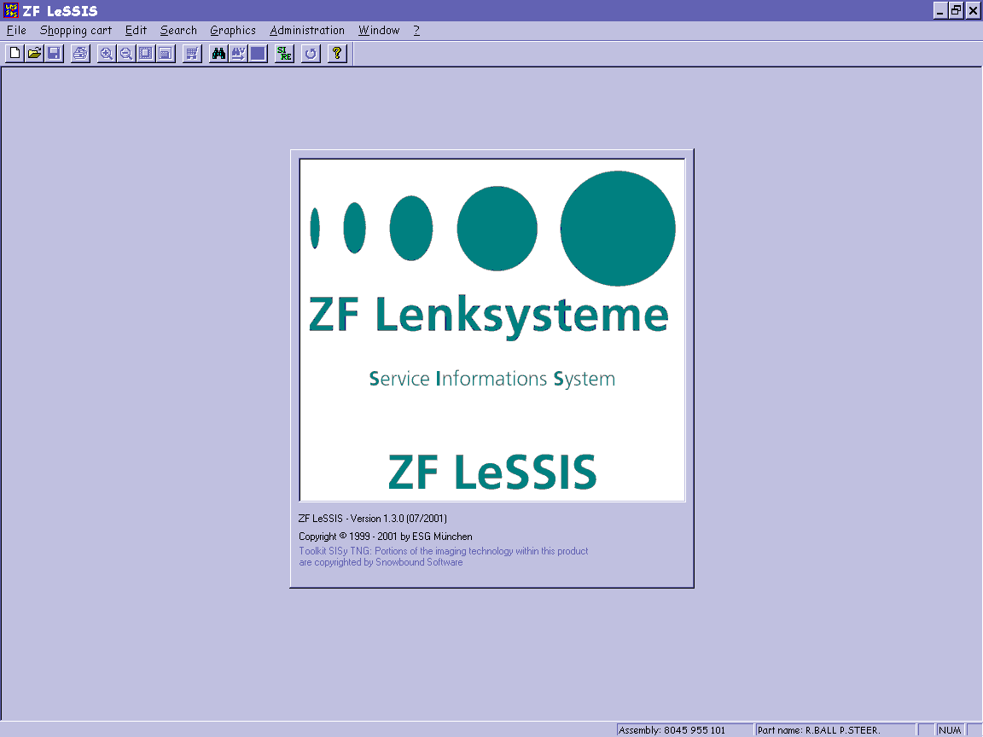
The splash screen can be closed prematurely by clicking on it with the mouse or pressing the Escape key. Then the main search mask is displayed.
ZF LeSSIS main window and main search mask
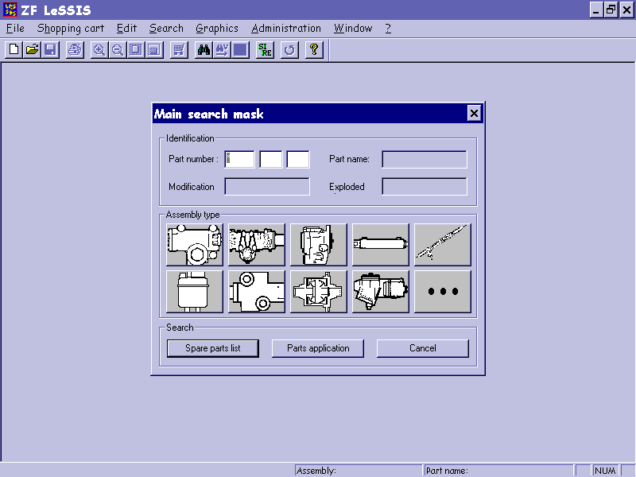

The user interface
The basic layout of the user interface and the structuring of its elements is based on the standard recommended by Microsoft so as to provide ease of learning and consistent application behavior within the Windows environment.

The main window
The main window constitutes the frame of the ZF LeSSIS application and always remains opened in the background during program execution. The menu bar, the tool bar, and the status line have a fixed position and are assigned directly to the main window. At the most, they can be made visible and hidden.
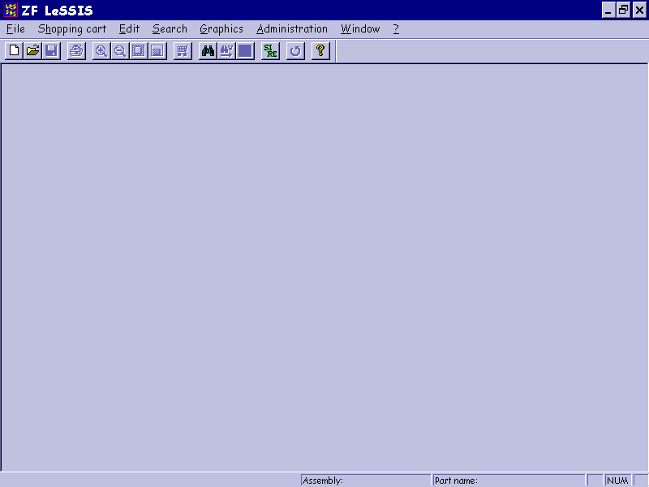

The toolbar
The toolbar is an alternative to the call of frequently used menu items of the main menu in the menu bar. It lists icons representing frequently needed functions and, if desired, it can be made visible or hidden below the menu bar.
The toolbar looks as follows:
The meaning of the individual elements is as indicated below:

New shopping cart
A new shopping cart is created.
Open shopping cart
The standard dialog for opening appears, and an existing shopping cart can be opened.
Save
The contents of the opened shopping cart can be saved. If a file name has not yet been assigned to the opened shopping cart, the standard "Save as" dialog for giving a file name is displayed.
Print
Printing of the current document.
This can be one of the following documents:
- assembly-group list and components list
- footnotes list
- current or all graphics (or graphics from - to)
- shopping cart
- complete parts list (assembly)
Before the start of printing, the standard print dialog for any further settings is shown.
Note:
A correct printout requires the existing installation of the font "Times New Roman" of the 8-point size.
Scale up
The graphic shown is scaled up. This button is active only if a graphic has been activated. The navigator is started up in the process.
Scale down
The graphic shown is scaled down. This button is active only if a graphic has been activated.
Adapt graphic
The graphic shown is adapted to the display window. This button is active only if a graphic has been activated.
Open/close navigation window
In an active graphic the navigation window is opened or closed.
Increase/reduce shopping cart
When this button is actuated, the shopping cart is reduced or increased. This button is inactive when no shopping cart is opened.
Main search mask
This button opens the main search mask and closes all opened documents, but the shopping cart remains opened.
Parts application search
This button opens the main search mask and enters a previously selected part number in the corresponding field of the main search mask. All opened documents get closed, but the shopping cart remains opened.
Comparison of parts lists (assemblies)
Starts the comparison of the currently opened parts list with another parts list, which is selected in the next program step.

Service Information documents / Repair Instructions
Opens a window in which all existing Service Information documents and Repair Instructions are displayed for selection.
Backward to the previous search step

Help
This button calls the help function.

The menu

The "File" function group
This submenu provides printer-specific functions. Additionally, the program can be terminated.

Menu item | Meaning
Print | Printing of the contents of the opened file/window or printing of the complete parts list (via the standard "Print" dialog)  Note:  A correct printout requires the existing installation of the font "Times New Roman" of the 8-point size.
Printer setup | Setup of the current printer and paper layout (via the standard dialog "Printer setup")
Terminate | Termination and closing of the ZF LeSSIS program

The "Shopping cart" function group
Commands are available for the shopping cart. To provide optimum support for the correct guiding of the shopping cart by the user, only one shopping cart is allowed to be opened at any time.

Menu item | Meaning
New | Creation and opening of a new (empty) shopping cart
Open | Opening of a shopping cart (by means of the standard dialog "Open file”)
Close | Closing of the opened shopping cart (with the query whether the changes are to be saved)
Save as | Saving of the opened shopping cart under a new name (by means of the standard dialog "Save file as")
Save | Saving of the opened shopping cart (if the shopping cart is new, saving takes place via the standard dialog "Save file as")
Export | Saving of the opened shopping cart under a new name in an ASCII file of a special format (using the standard dialog "Save file as")
"Shopping cart X" | Reopening of the shopping cart concerned (which has already been opened)

The "Edit" function group
This menu refers to the basic editing operations Cut, Copy, and Paste (for instance in connection with the editing of a shopping cart form).

Menu item | Shortcuts | Meaning
Cut | Ctrl-X | Cutting of the selected text area into the buffer
Copy | Ctrl-C | Copying of the selected text area into the buffer
Paste | Ctrl-V | Pasting of the buffer contents to the current cursor position

General note:
The menu functions are available by means of the shortcuts. Please use the corresponding shortcuts (Ctrl-C and Ctrl-V).

The "Search" function group
The command for initiating search inquiries via the main search mask (opening of the main search mask) is available in this menu. Also, there is a menu item for going backward step by step during the search. Also, the comparison of two parts lists can be started here.

Menu item | Shortcuts | Meaning
New search | Alt-S | Opening of the main search mask to start a new search
Parts application | Alt-V | Search for parts application. Opens the main search mask and enters a previously selected part number in the corresponding field of the main search mask.
Comparison | Alt-G | Opens a window for entering the part number of a second parts list (assembly) to which the currently opened parts list is to be compared. Then the comparison is started.
Service /  Repair Info | Strg-I | Opens a window in which all existing Service Information documents and Repair Instructions are displayed for selection.
Backward |  | Backward to the display of the previous search step or search result

The "Graphics" function group
The graphics menu comprises all user options that are related to the graphics. There are for example functions for scaling up and down the view.

Menu item | Meaning
Adapt to window | Adaption of the display scale of the graphic with the result that the graphic is adapted to the size of the display window.
Scale up | Scaling up of the graphic shown and display of the detail position in the navigation window
Scale down | Scaling down of the graphic shown and display of the detail position in the navigation window
Navigate | Opening/closing of the navigation window for the graphic shown

The "Administration" function group
ZF LeSSIS provides in this function group the selection option for the data language, in which results of inquiries to the database are supplied, and/or the system language for the display of the ZF LeSSIS user interface (menu names, dialog texts, help, etc.). Also, the current database status can be called here.

Menu item | Meaning
System language | Selection of the language for the user interface, menus and dialogs by means of a submenu with the available languages German and English.
Data language | Selection of the language for the display of search results (part names) by means of a submenu with the available languages (German, British English, American English, French, Spanish, Italian and Portuguese).
About database | Display of the current database status with details such as version, date, range (using an information window)

The "Window" function group
The Window menu offers the user the possibilities of making visible or hiding elements of the main window of ZF LeSSIS.

Menu item | Meaning
Toolbar | Making visible/hiding the toolbar
Status line | Making visible/hiding the status line

Help menu ("?")
The Help menu provides options of online help and general information on the ZF LeSSIS application.

Menu item | Meaning
Index | Guide to the index of the help system (by means of Help window)
Use help | Guide to the help system with information on the use of Help (using Help window)
About ZF LeSSIS | Display of splash screen

The main search mask
The main search mask is made up of various entry fields and the group buttons for the various assembly types. As soon as the cursor is placed over a group button, so-called tooltips are displayed which show the number ranges of the assembly types. A search operation is initiated by clicking on a function button.
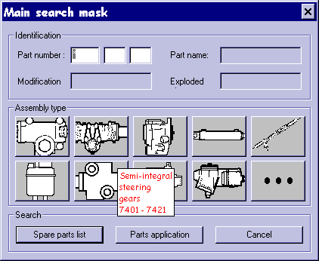

Part number for assembly or assembly group/component
The part number for assembly identifies one or, in case of partly qualifed entry, more assemblies (parts lists). The part number for assembly groups or components identifies exactly one assembly group or component each
Part name of assembly (cannot be selected in the current version)
Identifies one or more assemblies, assembly groups or components by way of the part name.
Modification number (cannot be selected in the current version)
Identifies one footnote each for assemblies, assembly groups or components.
Exploded view number (cannot be selected in the current version)
Identifies one or more assemblies each (one spare parts list).

Group buttons for assembly types

Icon | Assembly name | Part number for assembly type
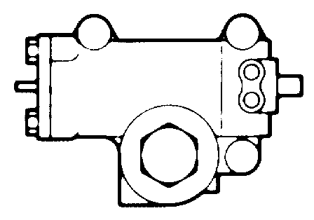 | Commercial vehicle recir-culating ball steering gears | 5980,  8012 – 8016, 8030 – 8046,  8056 – 8072, 8086 – 8099
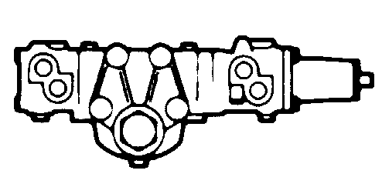 | Semi-integral steering gears | 7401 – 7421
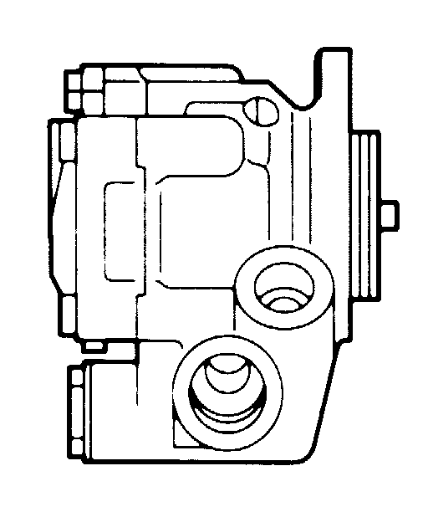 | Pumps | 7601 – 7677, 7680 – 7699,  8601 – 8608, 8681,  8691 – 8697, 8702 - 8706
 | Power cylinders | 8335 –8351, 8354 – 8479, 8481 – 8489
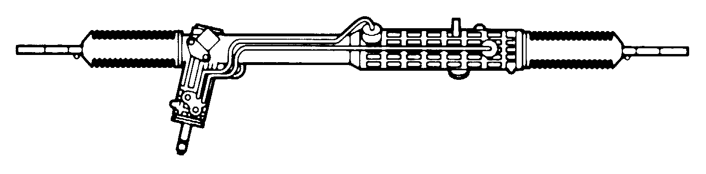 | Rack and pinion steering gears | 7802 – 7806, 7810 – 7859, 7875 – 7894
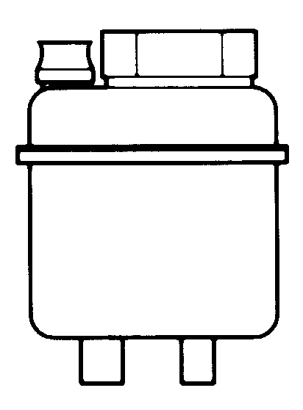 | Oil tanks | 7632, 7633, 7636, 7672,  center numerals 472  (digits 5-7)
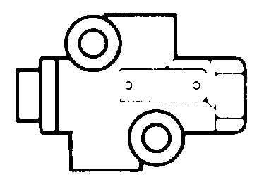 | Valves | 0501, 7700 – 7799,  8401 – 8404
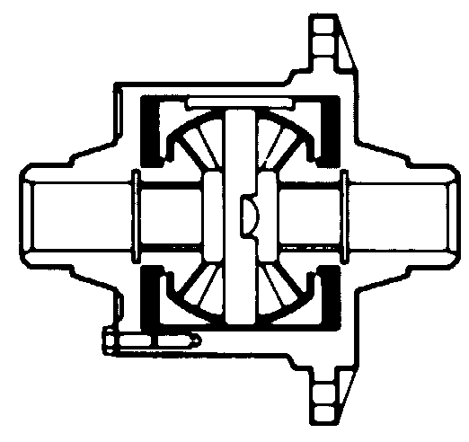 | Differentials | 4060 – 4061
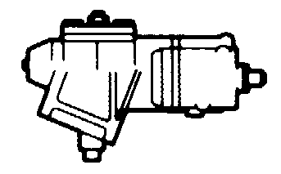 | Passenger car recirculating ball steering gears | 8050 – 8055, 8073 – 8076,  8080 – 8084
Icon | Assembly name | Part number for assembly type
... | Others | 4104, 7018, 7020 – 7023, 7025 – 7026, 7040, 7315, 7325, 7338, 7358,  7360 – 7370, 7860 – 7874,  8336, 8352, 8353, 8356, 8391 – 8393, 8480

Buttons

- Spare parts list
The search for a particular spare part is started.
- Parts application
The search for the application of a part (identified by the part number) within an assembly type is started.
- Cancel (close window - no search)

The results windows
The results windows for the assembly-group view and the components view are basically the same. One of the differences is that in the assembly-group view the header shows the part number of the assembly (parts list) and there is a button for the jump to the components, whereas in the components view the header shows the assembly part number and the assembly-group part number and there is an "Assembly groups" button for the return.
On the other hand, there is, in the assembly-group survey, the column "T" (type) in which the assembly-group is typified as Bauteil or component (B), as Ergänzungsteil or supplementary part (E), or as Reparatursatz or repair kit (R).
The display window is made up of three parts:
Graphics window (top left)
It shows all existing technical data cover sheets and exploded views.
Spare parts list (top right)
Depending on the level, the assembly groups of the assembly (parts list), or the components of the assembly group or of the repair kit, are shown here. Switching between assembly groups and components is done by button (see below) or with a double-click on the line of the requested spare part. The spare parts list is moved to the bottom border when a graphic is scaled up. The part numbers and modification numbers are shown colored.
Footnotes (bottom)
The bottom region shows the footnotes (modification number and reason for modification). The footnote can be displayed in a separate window by double-clicking on the footnote line.
Red color of the modification number indicates that there is a Service Information on this.
If the graphic is scaled up (double click on the graphic), the spare parts list is moved to the bottom border and the footnotes are displayed directly in the corresponding line.
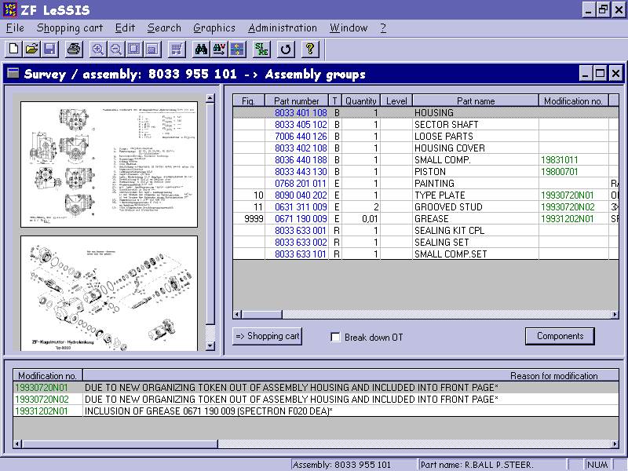
The navigation inside and between the windows is performed with the keyboard or mouse resp. and is in line with the usual standard of Windows programs.
The size of the single windows can be changed with the mouse. To do so, you position the cursor to the border region between the windows, press the left mouse button and drag the window, with the mouse button held down, to the desired size.
The display window provides the following buttons:
Shopping cart
Using this button, you can include in the shoppping cart the currently selected element on which the focus is in the spare parts list. Multiple selection and multiple inclusion are possible.
Master data (cannot be selected in the current version)
Master data are displayed of the part number which has been clicked on in the spare parts list.
Break down optional technical kit
If the click box "break down optional technical kit" is marked, all optional technical kits are displayed in breakdown form.
Components or assembly groups resp.
By means of this button you get to the components view of an assembly group or of a repair kit resp. or to the assembly-group view.
The same functionality is achieved by a double click on the line of the requested spare part.
The status line at the bottom end of the screen shows you the current or previous part number of the assembly as well as the part name of the assembly.

Selection of language

Data language
The selection of the so-called data language (rendering of part names, reasons for modification, etc.) is carried out by the menu "Administration –> data language".
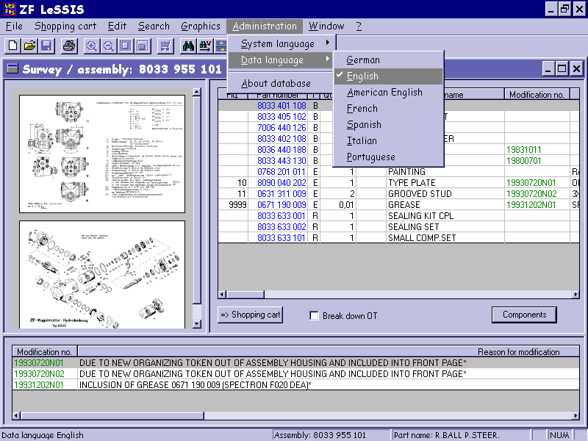
ZF LeSSIS offers here the selection option for all ZFLS languages. The language selected thus is activated when the next inquiry to the database takes place. The selection of the language has no effects on the ZF LeSSIS user interface (menu names, dialog texts, help, etc.).

System language
ZF LeSSIS additionally allows the display of the user interface (menus, dialogs, help texts, etc.) in the German or English language.
Selection is made by means of the menu item "Administration –> system language" and can take place during active operation. When another language has been selected, the dialogs, the user interface and the help text will be displayed in the language selected. This does not require a restart of the application.
The selection of another user interface language has no effects on the data language selected.
When the application is restarted, the system language selected last is loaded.

Search in ZF LeSSIS

Spare parts lists / Parts lists / Assemblies
It is possible to enter the part number in full or partly qualified in the main search mask and to choose additionally a group button.
If only one part number (in full or partly qualified) is entered, all the assemblies which suit the part number entered are displayed in a dialog window for further selection after the search function has been activated (by clicking on the "Spare parts list" button.
An assembly type can be selected by means of a group button. Selection using an assembly type is further limited by entering a precise part number or entering a part number that is partly qualified. Search is started by clicking on the "Spare parts list" button. The assemblies which suit the entry are displayed in a dialog window for further selection. If there is a conflict between the selected assembly type and the part number entered, the system calls attention to this by means of an error message.
The dialog window with the assemblies found is skipped if exactly one assembly is found during the search. If that’s the case, it is the assembly-group survey of the assembly which follows immediately.
Entry in main search mask
Results dialog window
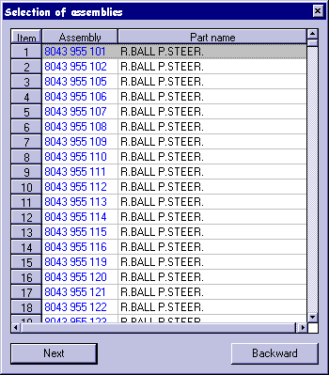
After a requested assembly number has been selected from the results dialog window, there follows the assembly-group survey with the technical data cover sheet, the exploded views, the assembly groups (including the repair kits and supplementary parts) as well as the footnotes.
The footnote/reason for modification pertaining to a part number is automatically highlighted as soon as a spare part is selected in the results window with the cursor/mouse. The footnote is displayed in a separate window when a double-click on the footnote line is carried out.
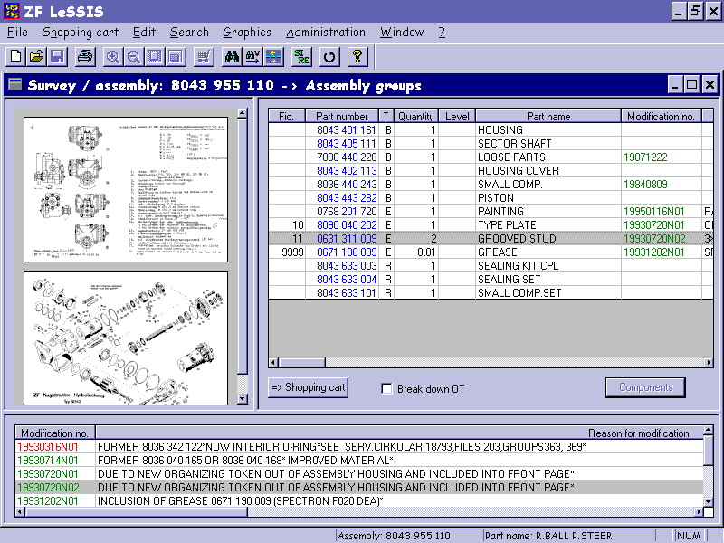
The following buttons are available in the display window:
Shopping cart
Using this button, you can include in the shopping cart the selected component on which the focus is in the spare parts list. Multiple selection and multiple inclusion are possible
Master data (cannot be selected in current version)
Master data are displayed of the part number which is clicked on in the spare parts list.
Break down otional technical kit
If the click box "Break down optional technical kit" is highlighted, all optional technical kits are displayed in breakdown form.
Components or assembly groups resp.
By means of this button you get to the components view of an assembly group or repair kit resp. or to the assembly-group view.
The same functionality is achieved by a double-click on the line of the requested spare part.

From the assembly group to the components
You can switch from the assembly-group survey to the components view by clicking on the "Components" button. Those components are displayed which belong to the selected assembly group. The further breakdown of an assembly group into components is possible only for assembly groups and repair kits (3rd column in the assembly-group survey with the identification letters "B" and "R"). In those cases the "Components" button can be chosen.
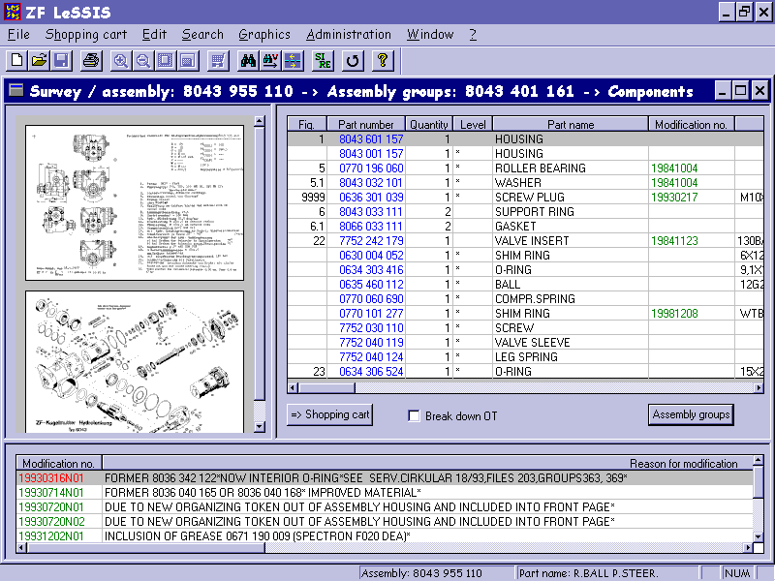
The status "-> Components" in the title bar shows that the selected assembly group is displayed in breakdown form. The "Components" button is renamed "Assembly groups" and allows the return to the assembly-group survey.
Switching from the assembly-group list to the components list is also possible by a double-click on the requested assembly group. If the components list is displayed, the effect of the double-click on a line in the components list is in any case a return to the assembly-group survey.
Alternatively, it is possible to return, whenever desired, from the components list to the previously opened assembly-group survey, using the "Backward" button (of the toolbar at the top).

From the graphic to the assembly group or component
At first it is required to scale up the graphic by a double-click on the same. The scaled-up graphic is displayed in the upper part of the screen. The assembly-group/components list is shown in the lower part. The level, assembly group or components, depends on the level chosen that has been displayed at the start of the scale-up function. It is only the display layout that changes. Here, too, you can change the size of the window with the mouse by positioning the mouse cursor on the window border, pressing the left mouse button and dragging the window to the desired size, with the mouse button held down.
It is now possible to select with the mouse a figure number in the exploded view or on the technical data cover sheet. To do so, hold down the left mouse button and select the desired figure number. Then the corresponding line (item) is automatically displayed highlighted in the assembly-group list/components list.
If ZF LeSSIS does not highlight a line, the number of the graphic was not recognized correctly (imprecise selection or lack of quality of the graphic).
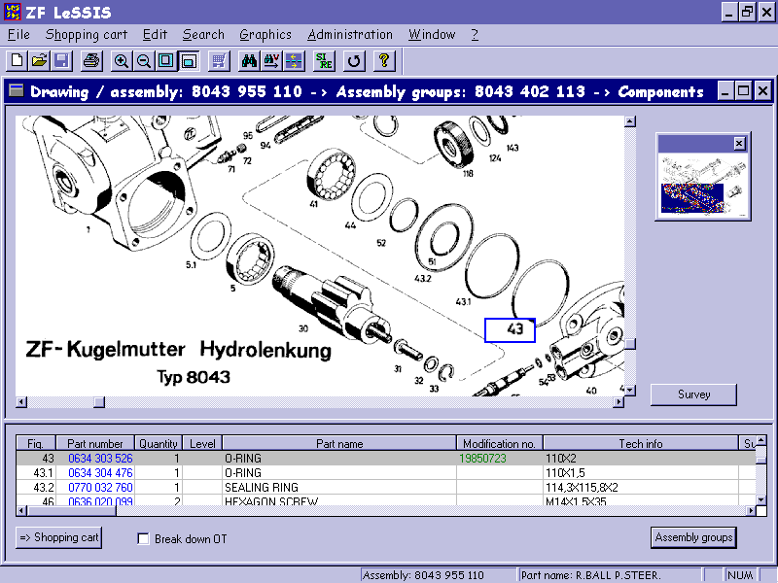
The main menu function group "Graphics" makes it possible to scale up or down the graphic displayed or to adapt it to the window size. When the graphic has been scaled up, the navigation window is shown where that area of the graphic is highlighted which is displayed in the graphic window. The highlighted area can be positioned inside the navigation window (click on it with the mouse, hold down the mouse button, and move). The area displayed in the graphic window moves in accordance with the movement of the highlighted area in the navigation window.

Search for spare parts in assemblies - parts application search
To carry out the "Parts application" function, it is necessary to enter the part number in the corresponding fields of the main search mask (using ' * ' as a wildcard is allowed in max. two fields). Subsequently, an assembly type has to be selected. The search function is started by clicking on the "Parts application" button.
There are four options for entering the part number:
- Manual entry of the number in the main search mask
Attention: Wildcard search with * * * are not allowed!
- Select the requested part number in a results window and put it in the Windows clipboard using the shortcut Ctrl-C. After the switch to the main search mask, paste this number into the entry field for the part number, using the shortcut Ctrl-V.
- Select the requested part number in a results window and open the main search mask with the requested part number, using the menu entry "Search -> Parts application" or the corresponding function button of the toolbar.
- Select the requested part number in a results window and open the context-sensitive menu with the right mouse button. By choosing the "Parts application" command of the context-sensitive menu, open the main search mask with the requested part number.
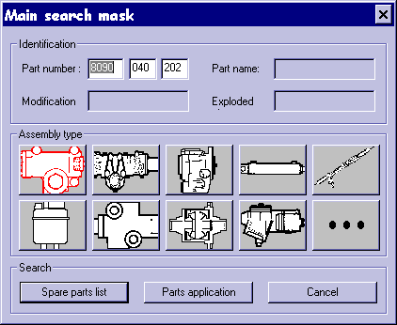
If the result of the query is bigger than 500 entries a dialog window appears. After confirming the first 500 entries will be shown.
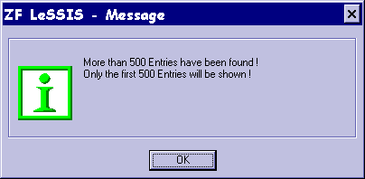
As a result, a dialog window is displayed which lists the assemblies/assembly groups/components combinations in which the part number exists.
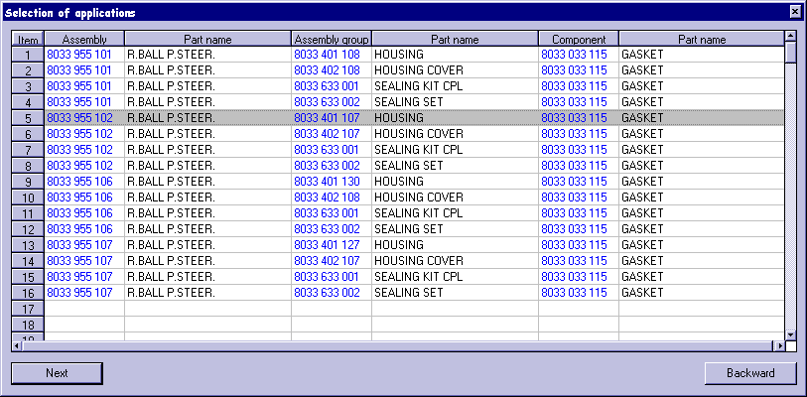
If the part number exists only at a higher level (e.g. assembly), the cells of the subsequent levels (e.g. assembly group and component) remain blank for such entry.
If there is one or more hits, the user can select a combination and get on to the assembly-group/components survey (spare parts list) by pressing "Next". The highlighting of the line is on the search key.
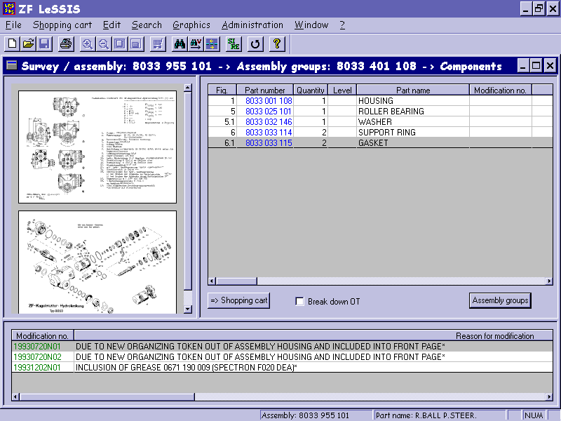

Search for Service Information documents and Repair Instructions
The Service Information documents were newly included in the version 1.1.0 of ZF LeSSIS. They replace the current Service Information documents on paper. From version 1.3.0, Repair Instructions are also available in ZF LeSSIS.
The Service Information (SI) document or Repair Instruction (RE) is shown in the current data language that has been selected. If the SI / RE is not available in the selected data language, the SI / RE concerned is displayed in the German language
The display tool required for Service Information documents and Repair Instructions is Acrobat Reader ® (from version 3.0). The Acrobat Reader ® version 5.0 is supplied with ZF LeSSIS. You will find it in the subdirectory "Acrobat Reader" on the CD "ZF_LESSIS_1". If required, you can install Acrobat Reader ® from there.
The search for Service Information documents is made either via the overall survey SI / RE or via the modification number of a component or assembly group. It is only via the overall survey SI / RE that you can have Repair Instructions displayed, because no modification number is related to these.

Survey of all Service Information documents and Repair Instructions
The search for all existing Service Information documents / Repair Instructions is started either by using the menu "Search -> Service / Instruction Info " or by clicking on the corresponding button of the toolbar.
All Service Information documents and Repair Instructions existing in the database are then displayed in a list.
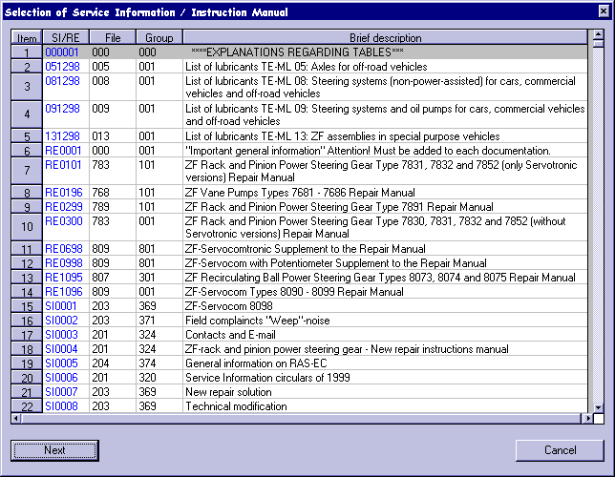
This selection window displays the available SI documents / REs in the preselected data language. If an SI / RE does not exist in the database in the selected language, the German version of the SI / RE is offered.
The SI documents / REs can be sorted by a single click on the column heading of a particular column. By default, sorting in line with the SI / RE number is offered. The document itself is called and displayed by double-clicking on the corresponding line in the list box or by "Next" button / Return.
The dialog can be terminated by clicking on the "Cancel" button .

From the assembly group / component to the Service Information
If a Service Information exists for a particular modification number, the modification number is marked red in the footnote. After selecting the relevant footnotes list (with the left mouse button), the pertinent Service Information can be called and displayed by means of a context-sensitive menu which appears after clicking on the right mouse button.
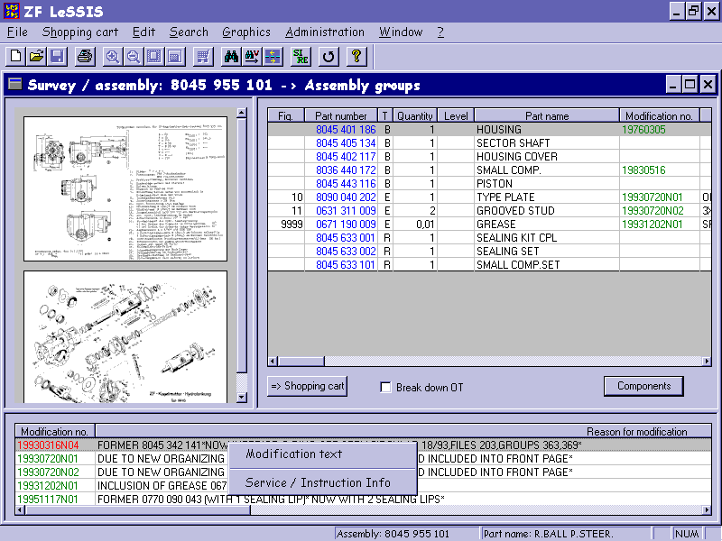
If there is only one Service Information for a particular modification number, it is displayed directly. If there are more Service Information documents for a particular modification number, a selection window opens which is similar to the selection window described above, and there the desired Information can be selected and displayed by double-clicking.
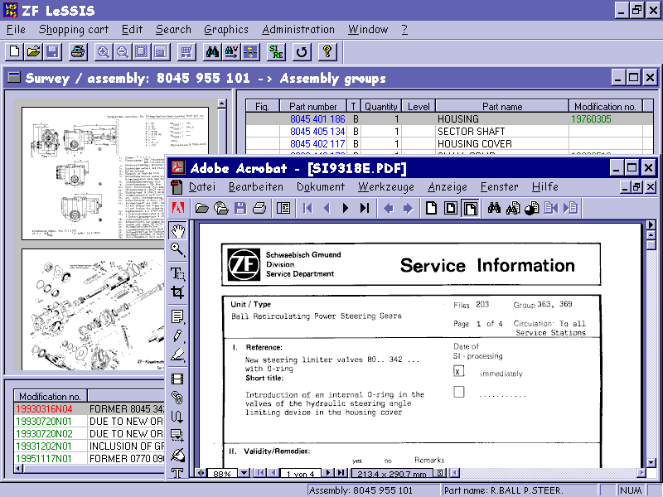
This type of display of the Service Information documents is possible only from the separate list of the modification texts, but not from the assembly-group list or components list.

Comparison of parts lists
Parts lists comparison aims at identifying differences in the make-up of parts lists (assemblies). In doing so, the part numbers of the elements of both parts lists, i.e. the assembly groups and components contained, as well as the frequency of their presence are compared to each other.
The result of the parts lists comparison details all differing parts of both parts lists and their respective frequency. With the assembly opened, the parts lists comparison can be started, and also printed, from the main menu or toolbar respectively.

Start of the parts lists comparison
The parts lists comparison is started from a results window of an assembly. To do so, you either select the menu item "Search -> Comparison" or click on the corresponding button in the toolbar. Then an entry window is opened into which the part number of the second parts list can be entered.
Eingabefenster für Sachnummer
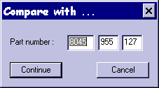
After its entry and acknowledgment by the button "Next", the comparison operation is started.

Result of the parts lists comparison
A progress bar in a separate window continuously shows the current status of the comparison until the result is displayed in a separate results window. The display covers the differing parts with graphic number, part number, type (for assembly groups, repair kits and supplementary parts), part name and frequency of presence in the parts lists.
Results window
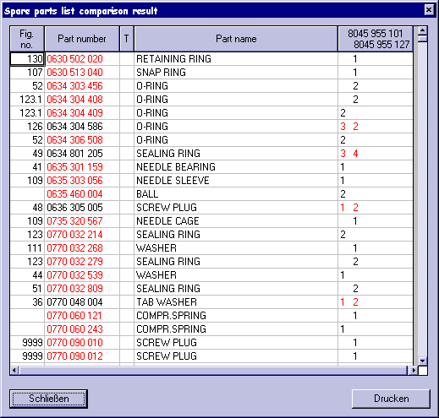
The result shown can be printed by clicking on the "Print" button.

Shopping cart

General
The user dialog "Shopping cart" corresponds to a form for ordering spare parts.
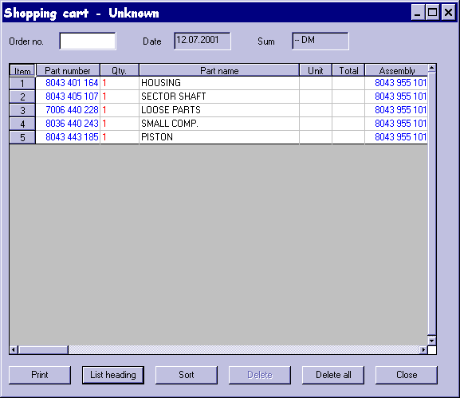

Items in the shopping cart
Items from the assembly-group list or components list can be included in the shopping cart by highlighting, in the list, the line containing the item and by pressing the "-> Shopping cart" button. The ordered quantity can be changed directly in the table.
If it is intended to include in the shopping cart parts identified by the sales codes 3 or 4 or by optional technical kit, a warning note will appear saying that this part cannot be ordered. But its inclusion is not ruled out, because it is nevertheless possible to include the requested part in the shopping cart.
The meaning of the buttons of the "Shopping cart" user dialog is as follows:
- Print
Printer output of the contents of the shopping cart.
Note:
A correct printout requires the existing installation of the font "Times New Roman" of the 8-point size.
- List heading
The focus is set on the first line in the shopping cart.
- Sort
The entries in the shopping cart are sorted by part numbers. The lowest part number is uppermost.
- Delete
The entry the focus is on is deleted.
- Delete all
All entries in the shopping cart are deleted.
- Close
The shopping cart is closed. If the contents of the shopping cart has not been saved, a dialog appears which requests the user to save the file. If a file name has not yet been given to the shopping cart, the standard dialog "Save file as" appears, and a file name can be indicated.

Export of a shopping cart
The shopping cart can be saved on the local hard disk as an ASCII file. The format of this ASCII file is as that of the ZF ELCAT.
An opened shopping cart can be exported to the ASCII file by means of the menu function "Shopping cart -> Export". After the function has been selected, a dialog appears which - similar to the standard dialog "Save file as" - requests the user to enter a file name and choose a directory. The directory "Export" is indicated by default.
As a result of acknowledgment by the "Save" button, the shopping cart is saved as an ASCII file.

Printing

General
Note:
A correct printout requires the existing installation of the font "Times New Roman" of the 8-point size.

The following ZF LeSSIS documents can be printed:

- Assembly-group list/components list
- Footnotes list
- Current graphic or all graphics (or graphics from - to)
- Shopping cart
From ZF LeSSIS version 1.3.0 it is also possible to print complete parts lists (assemblies).

- Parts lists (assemblies)

Start of printing
In the results windows, printing is started by clicking on the menu item "File -> Print" or the corresponding button (with the printer symbol) in the toolbar. Depending on the currently opened results window, the dialog window "Print selection – assembly-groups survey" or "Print selection – components survey" is opened. The user can choose what he wishes to print. The printing of the parts lists comparison can be started directly from the results window by actuating the "Print" button.
Note:
A correct printout requires the existing installation of the font "Times New Roman" of the 8-point size.

Parts lists (assemblies)
After the start of the printing process, the entry "Print the whole parts list" is selected in the print selection window and acknowledged by the button "Print ...". Then the standard print dialog for any further settings appears. The final printing process is initiated from the standard print dialog.

Assembly groups, components and footnotes
After the start of the printing process, the user can choose in the print selection window whether he wishes to print out the assembly-groups list, the components list or the footnotes list. After choosing the desired document and print acknowledgment by clicking on the button "Print ...", the standard print dialog for any further settings appears. The final printing process is initiated from the standard print dialog.

Graphics
After the start of the printing process, the user can choose in the print selection window which of the currently displayed graphics (one or more) he wishes to print out. After choosing the desired document and print acknowledgment by clicking on the button "Print ...", the standard print dialog for any further setting appears. The final printing process is initiated from the standard print dialog.

Parts lists comparison
In the results window of the parts lists comparison, printing can be started directly by actuating the "Print" button. Before the printing process begins, the standard print dialog for any further settings appears. The final printing process is initiated from the standard print dialog.

