

DaimlerChrysler
PAIS DVD

International

Installation Guide

Microsoft® Windows® 98
Microsoft® Windows® NT 4
Microsoft® Windows® ME
Microsoft® Windows® 2000 Professional
Microsoft® Windows® 2000 Server

Contents
1. System Requirements 1
Standalone Systems 1
Standalone Minimum Requirements 1
Client/Server Systems 2
Server Minimum Requirements 2
Client Minimum Requirements 2
2. Installing the Application: Standalone Systems 3
Activating Your Product License 7
Hiding the Windows Taskbar 7
3. Installing the Application: Client/Server 8
Install the Application on the Server 8
Activating Your Product License 12
Installing PAIS DVD International on a Client 13
4. Uninstalling PAIS DVD International 15

Copyright Notice
Information in this document is subject to change without notice. This document and any associated art work, software, product designs or design concepts are copyrighted with all rights reserved. Under the copyright laws, this document or designs may not be copied, in whole or in part without the prior written consent of ProQuest Business Solutions Inc. Under the law, copying includes translation to another language or format.
Copyright © 2002 ProQuest Business Solutions Inc. All rights reserved.
ePAR is a trademark of ProQuest Business Solutions Inc.
Microsoft, MS, and Windows are registered trademarks of Microsoft Corporation.
Documentation Feedback
At ProQuest, we strive to provide high-quality, easy-to-use printed and online manuals, guides, and instructional material. We continually work to improve the effectiveness and usability of our existing documentation, while developing new ways to help you get the most out of your ProQuest product. Please email your comments or suggestions directly to our Technical Communications Department at: documentation@pbs.proquest.com
Try to provide as much of the following information as possible:
- Your name, address, and phone number (optional).
- The name of your ProQuest product.
- The document type (printed or online).
- The document’s part number, revision number, and/or publication date.
Please remember that this email address is intended for documentation concerns only, and not for technical support or customer service. We look forward to hearing from you!
1. System Requirements

Standalone Systems
Your standalone system must meet the following minimum requirements before you can load the software.
Running more than one application at a time may affect speed and system performance. Additional hardware may be required to support other applications.
Standalone Minimum Requirements
Requirement | Minimum
System Software | Microsoft Windows 98/NT4WS/ME/2000P
Processor Speed | 266 MHz Pentium
Memory (RAM) | 64 MB
Available Hard Disk Space | 100 MB free (2 GB if the download option is chosen)
DVD Drive | One drive
Floppy Drive | 3.5-inch 1.44 MB diskette drive
Video Resolution | 1024 x 768; 16 bit (High Color)
Monitor | 15-inch minimum
Keyboard | Standard keyboard; membrane protected recommended
Mouse | Standard

Client/Server Systems
Your client/server system must meet the following minimum requirements before you can load the software.
Running more than one application at a time may affect speed and system performance. Additional hardware may be required to support other applications.
Server Minimum Requirements
Requirement | Minimum
System Software | Microsoft Windows NT4S/2000S
Processor Speed | 266 MHz Pentium
Memory (RAM) | 128 MB
Available Hard Disk Space | 100 MB free (2 GB if the download option is chosen)
DVD Drive | One drive
Floppy Drive | 3.5-inch 1.44 MB diskette drive
Video Resolution | 1024 x 768; 16 bit (High Color)
Monitor | 15-inch minimum
Keyboard | Standard keyboard; membrane protected recommended
Mouse | Standard

Client Minimum Requirements
Requirement | Minimum
System Software | Microsoft Windows 98/NT4WS/ME/2000P
Processor Speed | 266 MHz Pentium
Memory (RAM) | 64 MB
Available Hard Disk Space | 10 MB free
DVD Drive | Not required
Video Resolution | 1024 x 768; 16 bit (High Color)
Monitor | 15-inch minimum
Keyboard | Standard keyboard; membrane protected recommended
Mouse | Standard

2. Installing the Application: Standalone Systems
If your standalone system meets all minimum requirements, follow these steps to install the application on a standalone system.
- Close all programs and exit to the Windows Desktop. Insert the PAIS DVD International into a DVD drive.
- Click Start to open the Start menu, then Run to open the Run dialog box.
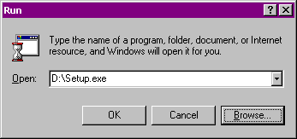
- In the Run dialog box, do one of the following:
  - In the Open: field, type D:\Setup.exe, then click OK,
Note: If necessary, substitute your DVD drive letter for “D:” in this example.
  - Or, click Browse and browse to the drive containing the PAIS DVD International. Click Setup.exe, then click OK.
The Select Language dialog box appears:
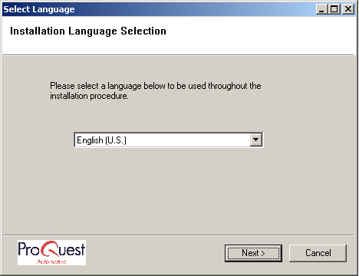
- Select a language, then click Next to open the Welcome window.
Note: If you do not have Java installed on your computer, it will be installed before the Welcome window opens. This may take a few minutes.
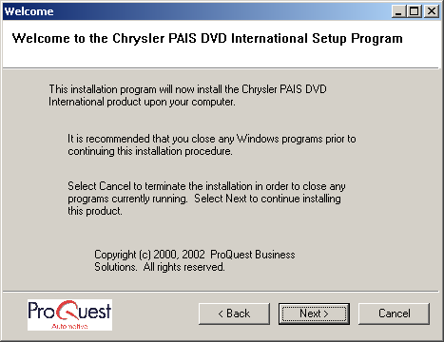
- Click Next to open the Restore Floppy window.
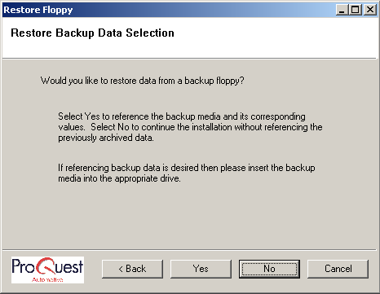
- To restore data from a backup disk, insert the disk into a drive, click Yes, then follow the onscreen prompts. Otherwise, click No to open the Select Data Groups window.
Note: The Product Licenser will be installed before the Select Data Groups window opens. This may take a few minutes.
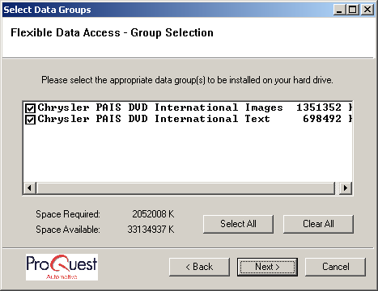

- Click the checkbox(es) next to the data group(s) you want to copy to your hard disk. Groups with an X will be copied in the checkbox. Click Select All to copy all data groups, or click Clear All to clear all the checkboxes.
Hint: Checking a box in the Select Data Groups window increases the time it takes to run the update. If you plan to run the EPC with the DVD in the DVD drive, you do not need to check any boxes.
- Click Next to open the Select Disk Allocation dialog box (see Table 1).
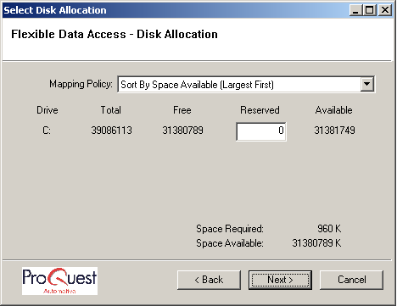
Table 1: Understanding the Select Disk Allocation Dialog Box
Mapping Policy | Shows how the drive(s) on your system are listed in the dialog box. They can be "Sorted by Space Available (Largest First),” “By Drive Letter (A to Z),” or “By Drive Letter (Z to A).” This box may change the order in which the hard disk drives are listed in the dialog box.
Drive, Total, Free, and Reserved columns | For each hard disk drive in your system (listed by volume letter), these columns show total space, free space, a field for you to type how much space you want to reserve as free, and the resulting available space.
Reserved Fields | These fields allow you to type the amount of space you want to keep free on a particular disk. Caution: Do not fill all your available hard disk space. Some free disk space is necessary for the operating system, for product installation, or for additional programs.
Available | Shows how much hard disk space is available on each drive.
Space Required | Shows how much hard disk space is needed to copy the selections.
Space Available | Shows how much total hard disk space is available.
Back | Returns you to the Select Data Groups window.
Next | Continues the installation process.
Cancel | Click to cancel the installation process.

- Click Next to begin copying files from the DVD. A Progress Indicator monitors the installation's progress.
- When the installation is complete, the Complete window appears. Click Finish.
The DaimlerChrysler PAIS DVD International EPC is now installed to your standalone system. To begin using the application, you must first activate a product license. The following section describes how to do so.

Activating Your Product License
Before you can use the application, you must have an active product license. Product Licenses for standalone systems are installed and activated automatically during the installation process. You do not need to do anything else to activate the license and use the application. You must, however, run a monthly update each month when you receive an updated DVD copy to ensure that the license remains active.

Hiding the Windows Taskbar
After installation, the Function Key Display appears at the bottom of the screen. It may be hidden by the Windows taskbar, making the keys inaccessible. If so, you have three options:
- To keep the taskbar active and not use the Function Key Display, do nothing.
- To keep the taskbar active and hide the Function Key Display, use User Utilities to turn the function key display off. You can turn the display back on at any time with the same utility.
Note: For information about User Utilities, Selecting User Utilities in the User's Guide, which can be accessed through the Chrysler PAIS DVD International icon that appears on your Windows Desktop after installation.
- To use the Function Key Display, do the following to hide the taskbar:
a). Click Start, then Settings, then Taskbar & Start Menu to open the Taskbar Properties dialog box.
b). Make sure the Always on top and the Auto hide checkboxes are checked.
c). Click OK. To reactivate the taskbar in the future, check the Auto hide checkbox.
3. Installing the Application: Client/Server
Install the Application on the Server
If your system meets all minimum requirements, follow these steps to install the application to the server. Note: You must be logged in as Administrator to install the application.
- Close all programs and exit to the Windows Desktop. Insert the PAIS DVD International into a DVD drive.
- Click Start to open the Start menu, then Run to open the Run dialog box.
- In the Run dialog box, do one of the following:
  - In the Open: field, type D:\Setup.exe, then click OK,
Note: If necessary, substitute your DVD drive letter for “D:” in this example.
  - Or, click Browse and browse to the drive containing the application DVD. Click on Setup.exe, then click OK.
The Select Language dialog box appears:
- Select a language, then click Next to open the Welcome window.
Note: If you do not have Java installed on your computer, it will be installed before the Welcome window opens. This may take a few minutes.
- Click Next to open the Restore Floppy window:
- If you want to restore data from a backup disk, insert the disk into a drive, click Yes, then follow the onscreen prompts. Otherwise, click No to open the Select Data Groups window.
Note: The Product Licenser will be installed before the Select Data Groups window opens. This may take a few minutes.
- Click the checkbox(es) next to the data group(s) you want to copy to your hard disk. Groups with an X in its checkbox will be copied. You can also click Select All to copy all data groups, or click Clear ALL to clear all the checkboxes.
Hint: Checking a box in the Select Data Groups window increases the time it takes to run the update. If you plan to run the EPC with the DVD in the DVD drive, you do not need to check any boxes.
- Click Next to open the Select Disk Allocation dialog box (see Table 2).
Table 2: Understanding the Select Disk Allocation Dialog Box
Mapping Policy | Shows how the drive(s) on your system are listed in the dialog box. They can be "Sorted by Space Available (Largest First),” “By Drive Letter (A to Z),” or “By Drive Letter (Z to A).” This box may change the order in which the hard disk drives are listed in the dialog box.
Drive, Total, Free, and Reserved columns | For each hard disk drive in your system (listed by volume letter), these columns show total space, free space, a field for you to type how much space you want to reserve as free, and the resulting available space.
Reserved Fields | These fields allow you to type the amount of space you want to keep free on a particular disk. Caution: Do not fill all your available hard disk space. Some free disk space is necessary for the operating system, for product installation, or for additional programs.
Available | Shows how much hard disk space is available on each drive.
Space Required | Shows how much hard disk space is needed to copy the selections.
Space Available | Shows how much total hard disk space is available.
Back | Returns you to the Select Data Groups window.
Next | Continues the installation process.
Cancel | Click to cancel the installation process.

- Click Next to begin copying files from the DVD. A Progress Indicator monitors the installation's progress.
- When the installation is complete, the Complete window appears. Click Finish.
The PAIS DVD International EPC is now installed on the server. Next, you must activate your product license.

Activating Your Product License
Product Licenses for Windows 2000 Server or Windows NT4 Server systems are installed from a floppy disk that are available from your DaimlerChrysler Distributor contact.

To install and activate the license:
- Insert the product license floppy diskette into the server's floppy disk drive.
- Use Windows Explorer to navigate to the floppy.
- Double-click the product license icon. The license will install automatically to the server's hard drive.
- Remove the product license floppy from the disk drive.
Your product license is now activated. You will need to repeat this process every 6 months. Updated product license floppy disks will be made available to you through your DaimlerChrysler Distributor contact.

Installing PAIS DVD International on a Client
A PAIS DVD International Windows 2000 or NT client/server network can include Windows 98, ME, 2000 Professional or NT4WS systems as clients.
1. When the server installation is complete, log on each client by holding down the CTRL and ALT keys at the same time and pressing the DELETE key to open the Logon Information dialog box.
Enter a user name and password that is valid for this system.
User name:
Password:
Domain:
2. Log in with a user name that has administrative privileges. Then click OK. The Windows Desktop appears.
3. Click Start, then Run, to open the Run dialog box.
4. Click the Browse button to open the Browse dialog box, then select Network Neighborhood from the drop-down list.
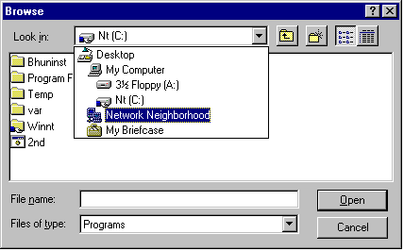
5. Once you select Network Neighborhood, the network components (server, clients, etc.) are listed in the Browse dialog box. Click the name of the server for your NT client/server network. The server name shown below is an example only.
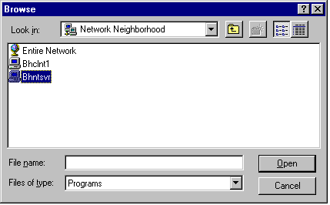
7. Once you select the server, select the cypi-cypi folder to open a list of folders.
8. Double-click the Install folder to open a list of files in the folder.
9. Click clisetup.exe, then click Open.
10. Click OK.
11. When the Choose Setup Language window appears, select your preferred language, (English (U.K. or U.S.), German, Italian, French, Portuguese or Spanish), then click OK.
12. When the Welcome window appears, click Next. Setup will finish the automated installation process. When the Setup Complete window appears, click Finish.
13. Open the application by clicking the PAIS DVD International icon from the Windows Desktop or using the Start, Programs, and PAIS DVD International menus.
4. Uninstalling PAIS DVD International
Use this procedure only if you want to remove PAIS DVD International from your system. If you uninstall PAIS DVD International from an NT or Windows 2000 client/server network, uninstall the clients first. Perform the following steps on each client and the server.
- Click Start, then Settings, then Control Panel to open the Control Panel window.
- Double-click the Add/Remove Programs icon to open the Add/Remove Programs Properties dialog box.
- Click PAIS DVD International to highlight the entry.
5. Click the Add/Remove button to display a Confirmation File Deletion prompt.
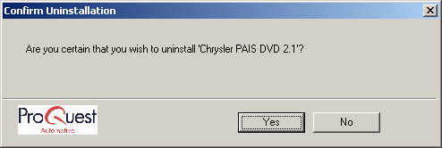
6. Click Yes.
7. When the process is complete, the Remove Programs From Your Computer window will show Uninstall successfully completed. Click OK to close the window.
8. The Add/Remove Properties dialog box and the Control Panel window will still be displayed. To close them, click the X in the top right corner of each window.

